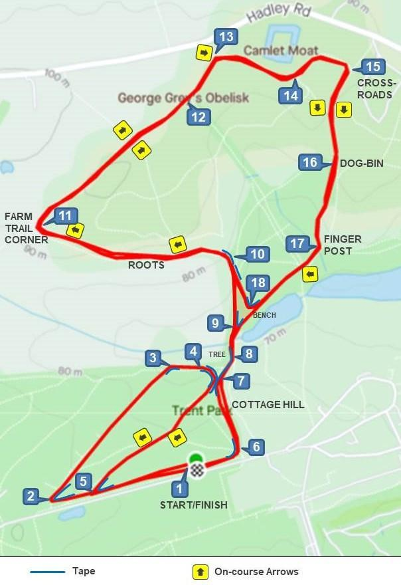 Start on top field via points 1 to 9 and then twice round loop at points 10 to 18 then back to finish via points 9 to 6 and then finish at point 1.

