
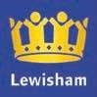

Photo

courtesy

of

Andy

Cox

supported

by

SOUTHERN

MAIN

C
ROSS COUNTRY

CHAMPIONSHIPS

Saturday 25
th

January 2025

Beckenham Place Park, London BR3 1SY
&

Race 1 | 11.00am | Under 15 Boys | 4,500m
Race 2 | 11.20am | Under 13 Girls | 3,000m
Race 3 | 11.35am | Under 13 Boys | 3,000m
Race 4 | 11.50am | Under 15 Girls | 4,500m
Race 5 | 12.10pm | Under 17 Men | 6,000m
Race 6 | 12.40pm | Under 20 Women | 6,000m
Race 7 | 1.05pm | Under 17 Women | 6,000m
Race 8 | 1.30pm | Senior Women | 8,000m
Race 9 | 2.10pm | Under 20 Men | 8,000m
Race 10 | 2.35pm | Senior Men | 15,000m

Numbers are to be collected from the Mansion House.

For the first 5 races (U15B, U13G, U13B, U15G, U17M) Numbers will be available from 9 am.
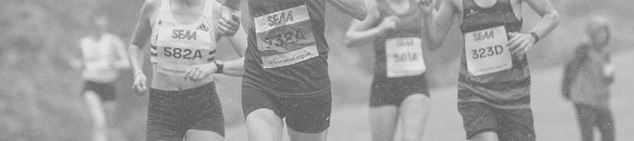
For the last available 5 races, numbers will be available from 11am.

ON

THE

DAY

The medical details on the back of the number must be completely filled in. This is to be filled in to ensure first aiders and officials are able to act appropriately in the event of an accident.

In the interests of the health and safety of our officials and volunteers, there will be a cut off time. SENIOR MEN’S RACE - Note to Team Managers and Individual Athletes.
You are respectfully reminded this is a Championship event. In the interests of health and safety of our officials and volunteers we have found it necessary to have a cut off time.
Times will stop being recorded after 90 minutes. There will be a cut off at the 8km point after 50 minutes - and athletes will not be allowed to finish the race if they have not reached this point by this time.

Chip timing will be used. Results will be available on the day via the QR code at the venue.
There are no changing facilities available.
Please note that any commercial logo included on a club vest MUST be registered with UKA.
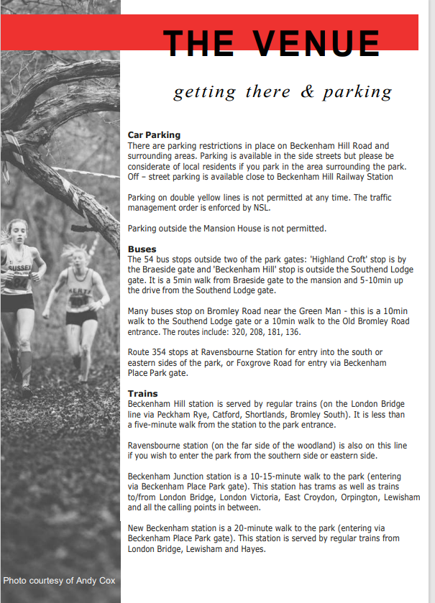
sf Andy Cox

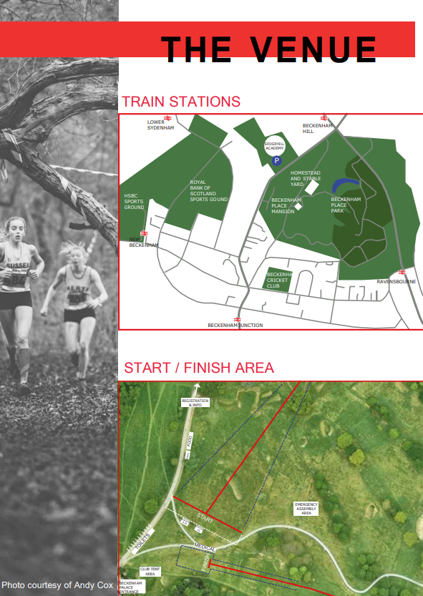
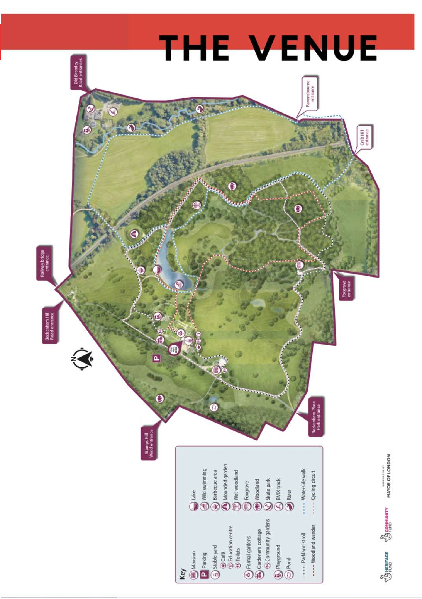
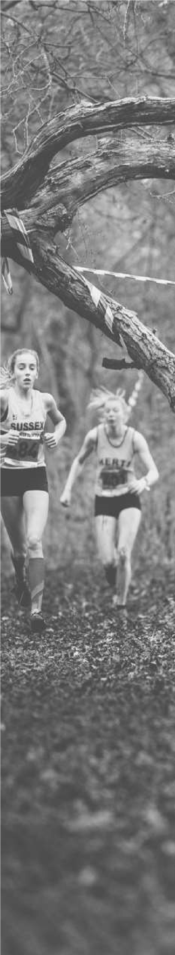



THE

VENUE

other information

Refreshments

Beckenham Place Park

Homestead Café

and bar are situated in a beautifully restored
Georgian Stable block in Beckenham Place Park.

Mansion House
has a café bar and small restaurant.

Beckenham Town Centre

There are a number of restaurants, cafes & pubs in the town centre for catering for
all
tastes. It is a 15
minute walk to the beginning of the

town centre
Beckenham Place Park entrance

Useful tools to plan your journey
- Transport for London journey planner to plan your journey by bike, on foot or by public transport
- National Rail for public transport information
- Lets Ride provides cycle route maps, descriptions and downloadable files that are all free to download and accredited by British Cycling.

