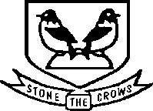

2024 Sunday Cross Country League Royston Runners Event at Therfield Heath, Royston

Sunday, 18 February 2024. Start at10:30am.

Race HQ. The Heath Sports Club, Baldock Road, Royston, SG8 5BG

Closest post code is SG8 5BJ. (Post code for The Heath Sports Club locates the venue at the nearby golf club). What3Words: blurred.width.cuff

Directions. You can get to Therfield Heath from the A505, A1198 or A10.

Car sharing – Please car share where possible. Parking – please follow the instructions of the marshals wearing yellow tabards.

Train. IMPORTANT – no trains will be running from London and elsewhere to Royston on 18 February.

Facilities. There will be temporary toilets and urinals onsite for runners to use. Please do not use the toilets in The Heath Café as these are for patrons of the café.

Refreshments and bar are available in The Heath Café.

Please be aware that rugby matches and training sessions will be taking place in the area between the race start/finish and The Heath Cafe. Please DO NOT walk through this area and disrupt training sessions.

Please note that all muddy footwear must be removed before entering The Heath Sports Club Cafe, especially spikes. Please help us to maintain good relations with the cafe by adhering to this request!

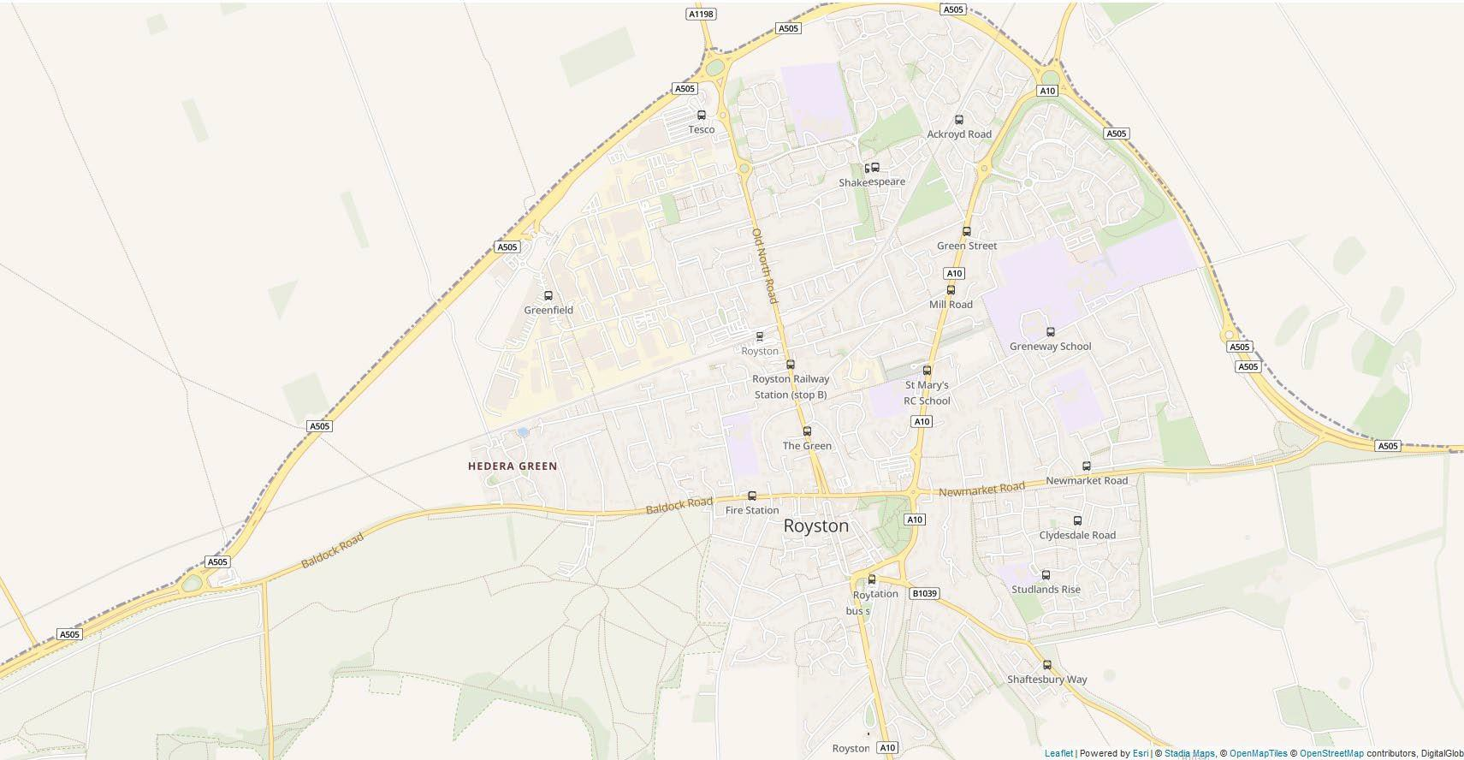
The Heath Sports Club

